

Egypt University of Informatics

Computer and Information Systems

Data Analysis Course

The Analysis of education preference.

Submitted by: Amr El Azazy

22-101237

# Introduction

Universities, once the undisputed path to a successful career, are facing growing criticism. Soaring tuition costs, mountains of student debt, and a perceived disconnect between academic pursuits and real-world job skills are causing many to question the value of a traditional university education. But what are the alternatives? This report dives into the growing popularity of alternative education options, exploring whether students are turning towards technical training or online learning to bridge the gap between education and their career aspirations.

# Research Question

# **Do students perceive traditional university education as effectively preparing them for the job market, and if not, what alternative educational pathways are they drawn towards (technical training or online courses)?**

# Hypothesis

**I hypothesize that a significant portion of the surveyed population will express dissatisfaction with the job market preparedness offered by traditional universities. Furthermore, we expect a preference for alternative education options, such as technical training or online courses**

# Population of Interest:

This survey targets individuals aged 18-70, encompassing recent high school graduates, those considering career changes, and anyone interested in pursuing further education.

# Sampling Method:

We will employ a random sampling method. This approach ensures a fair representation of the population of interest. Random sampling techniques, like online survey platforms with diverse user pools, or phone surveys using random digit dialing, will be utilized to gather data from a representative sample of the target population.

# Bias Identification:

.

# Survey Questions:

[Age]

[Gender]

[Do you prefer to universities education?]

[If no, what do you prefer from these?

(Technical education or Online education courses)]

Number of sample collected : 32

# Analysis:

|  |
| --- |
|  |
| The Chart Showing that numerous individuals opt for technical education because of the advantages offered by the acquired skills and employment opportunities. However, there is also a considerable number of students who favor online courses. |

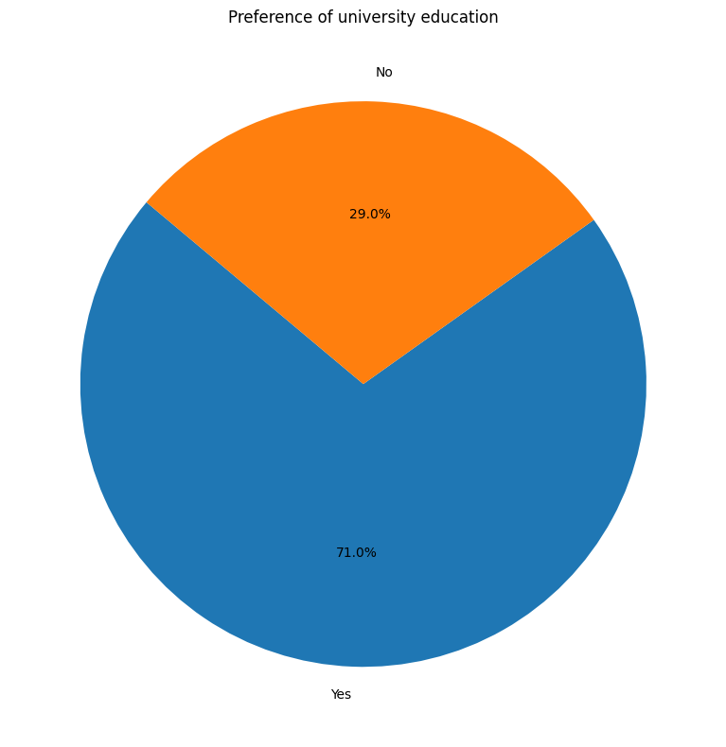

The chart illustrates that many students support traditional university education, likely influenced by various factors such as the development of communication skills, networking opportunities, and numerous other benefits associated with this form of education.

# Conclusion

This survey investigated the educational preferences of university students amidst concerns about the job market preparedness offered by traditional universities. The findings revealed a significant interest in alternative education options.

A substantial portion of respondents expressed a preference for **technical education**, highlighting the value they place on acquiring **job-specific skills**. This aligns with the hypothesis that students are seeking more direct pathways to career readiness.

The survey also indicated a notable interest in **online courses**. This suggests that flexibility and accessibility are important factors for university students considering alternative education options.

.